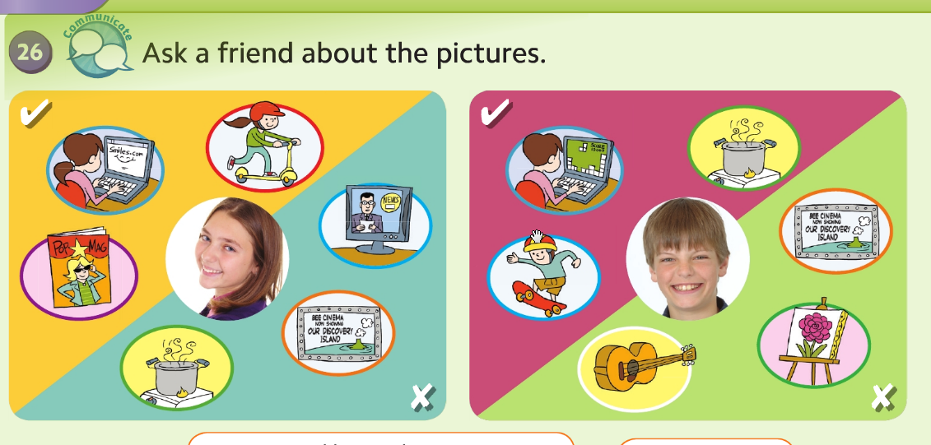
Escribimos en nuestro cuaderno la fecha y copiamos las preguntas que hay abajo.
Tuesday, 20th October, 2020
26. Answer the questions with:
Yes, she does -- Yes, he does
No, she doesn’t -- No, he doesn’t
Does she like cooking?
Does she like reading magazines?
Does she like watching TV?
Does she like riding a scooter?
Does he like playing the guitar?
Does he like painting?
Does he like skateboarding?
Does he like playing computer games?

